Advanced Software Engineering

Lab 4

Create a Web Service by selecting new --> web site and right click on service and add an item Web Service.

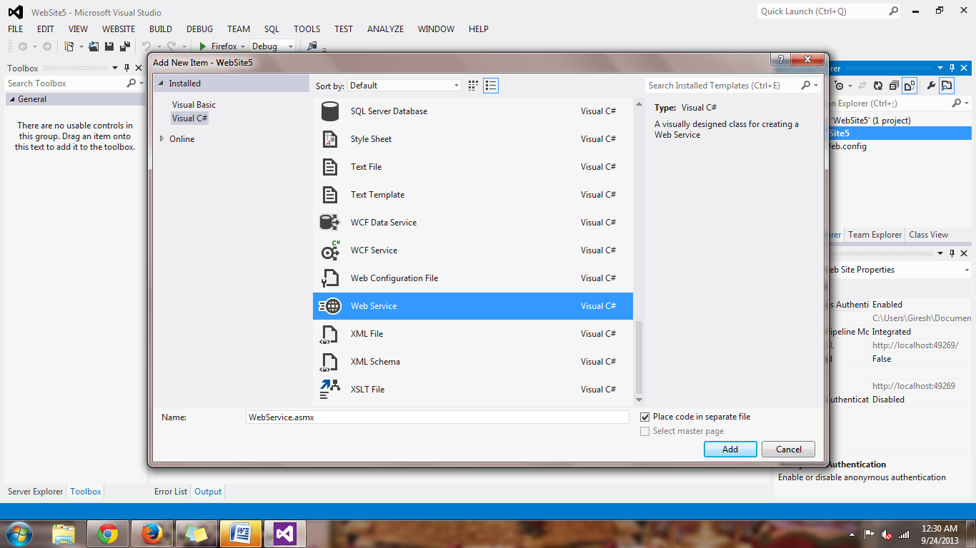

Then write the code that responds to the basic arithmetic operations as below

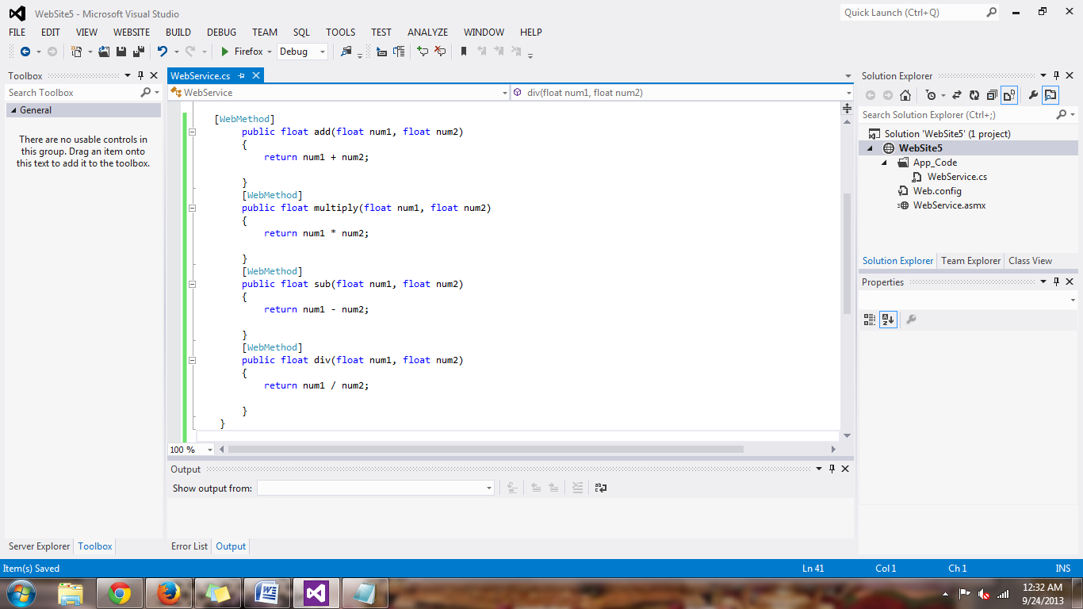

Then build the function and start without debugging and the methods are displayed as below

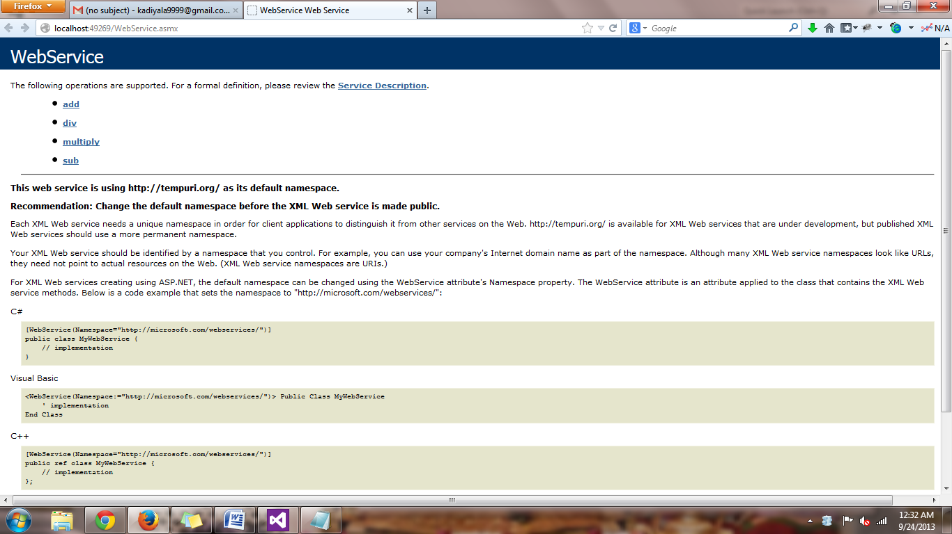

Then the local web service is deployed in to the cloud

Login in to the cloud and paste the website file from the local machine to the cloud C:\inetpub\wwwroot\aspnet_client

Now I opened the Internet Information Services IIS Manager and check for the file under the Websites

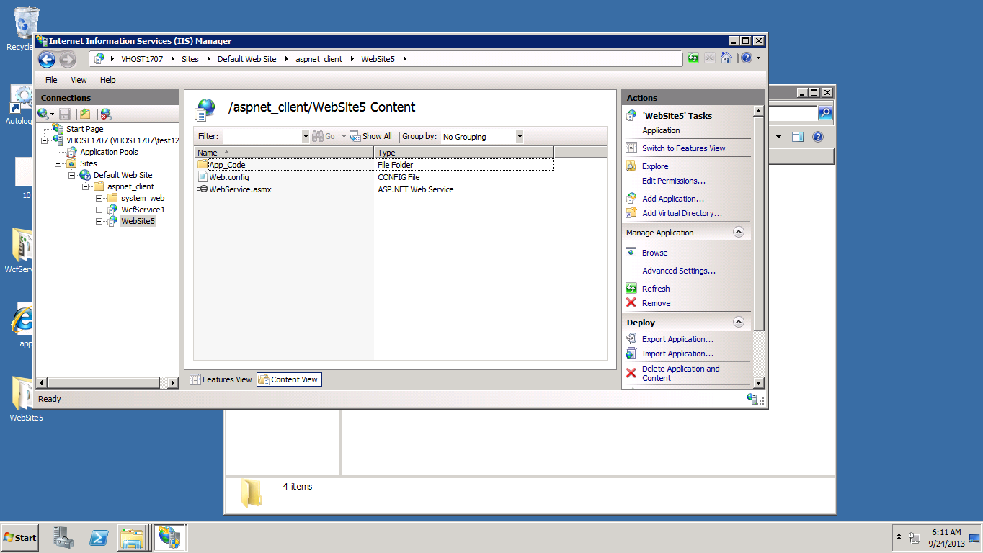

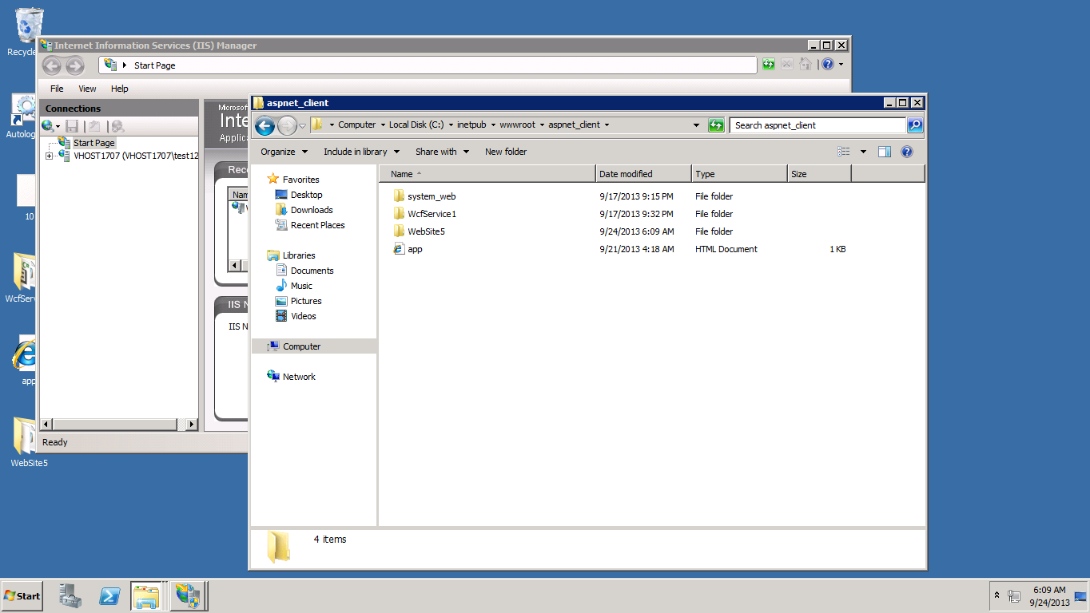

Then after deploying the Web service in the IIS of the cloud then right click the web service .asmx and open in the browser

Now we see the following methods in the services.

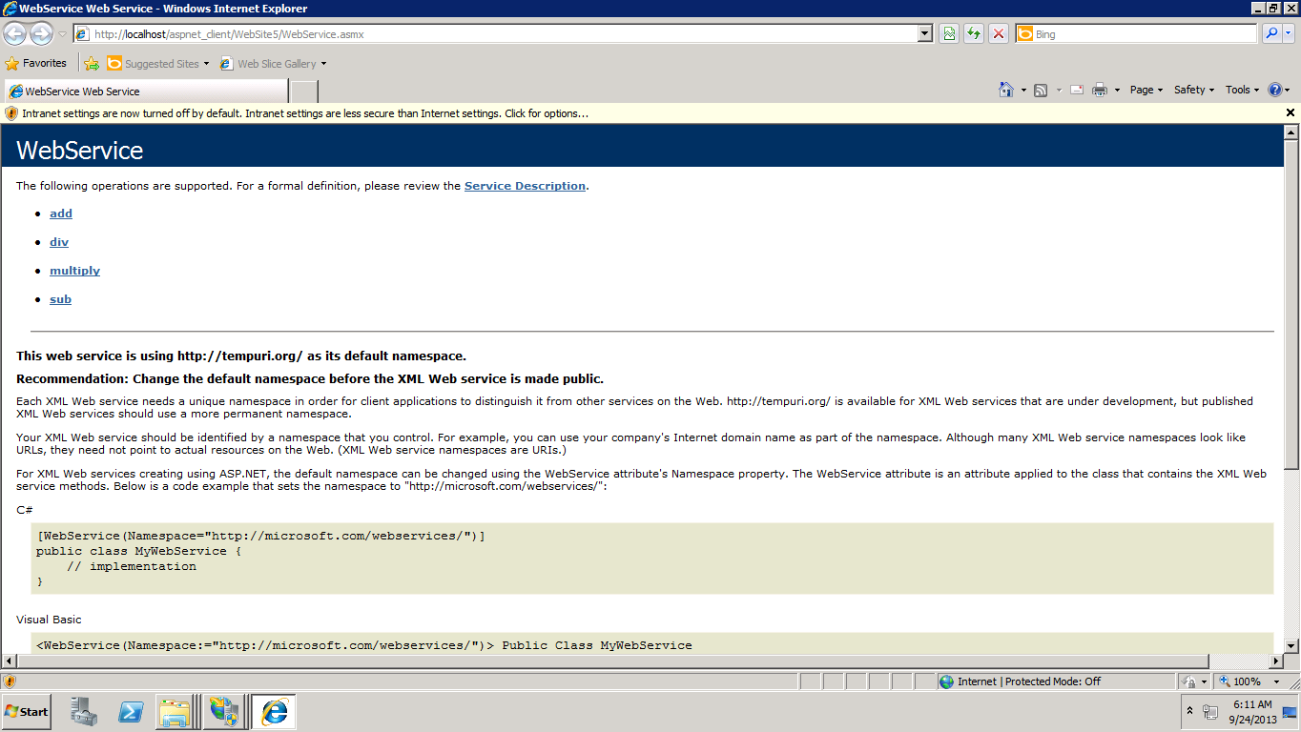

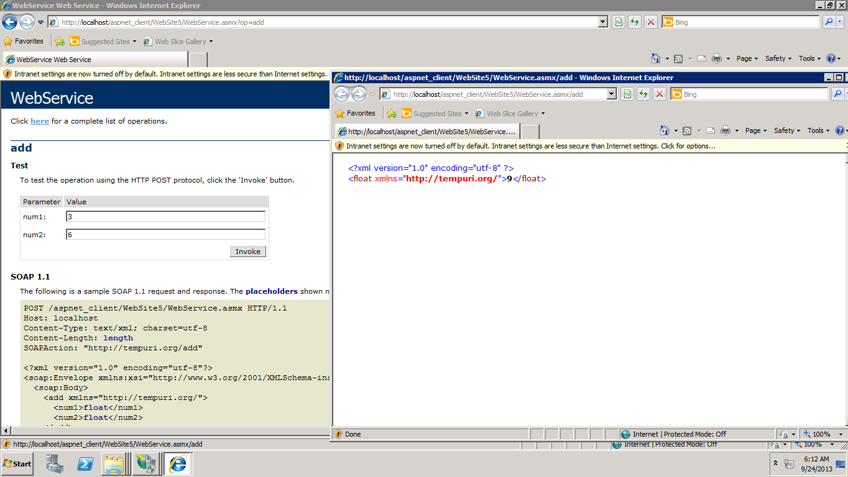

Now invoke them to see the addition functionality as above .

**The Multiplication function is as below.**

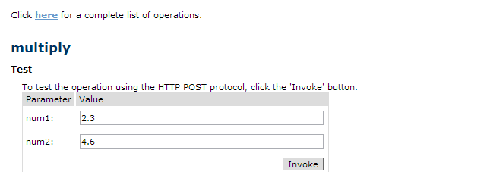



**The Subtraction Functionality is as below**

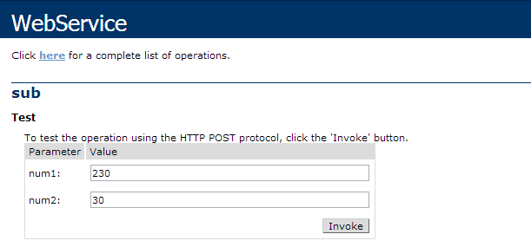

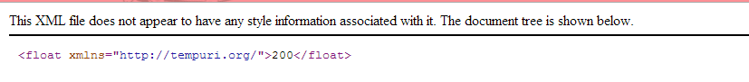

**The Divisibility function is as below**

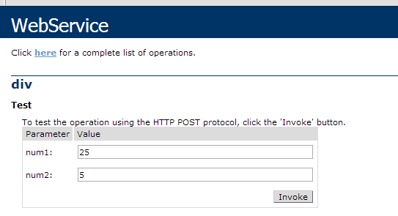

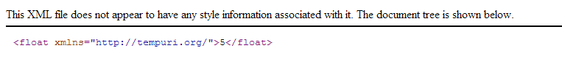

.

My soap web service remote :

<http://vhost1707.site1.compute.ihost.com/aspnet_client/WebSite5/WebService.asmx>

**Creating the Web Client Application**

I created a new Website in the visual studio and then add the new item as the webform

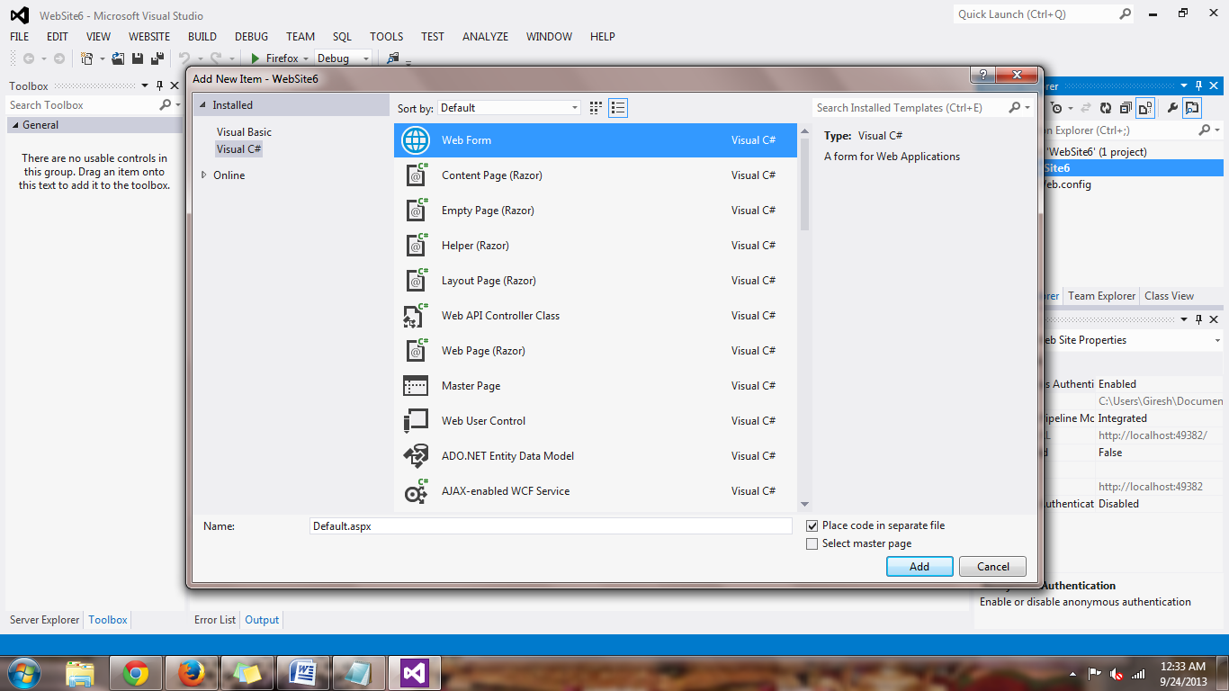

Step add the service reference to the web form by the cloud deployed Saop service by the url :

<http://vhost1707.site1.compute.ihost.com/aspnet_client/WebSite5/WebService.asmx>

Now create a form in the Default.aspx page by dragging and dropping as shown

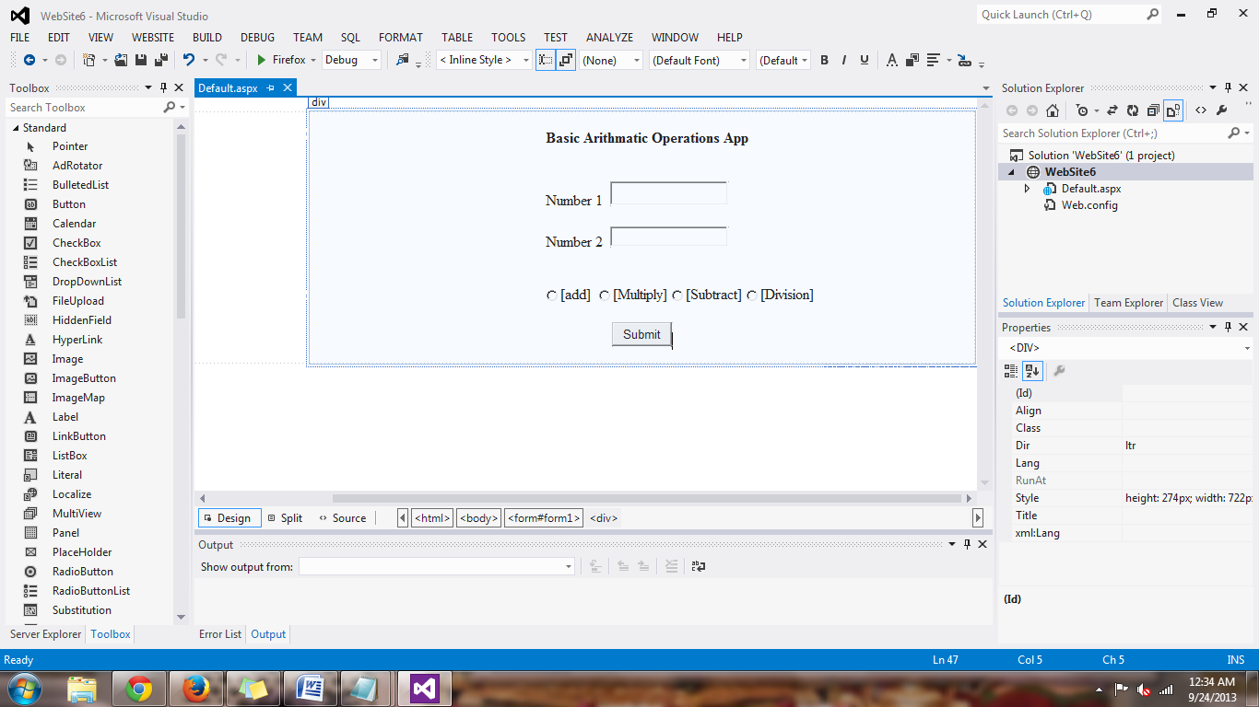

Then I created a new web form as shown above and then right click on the project and add a web reference and select ok.

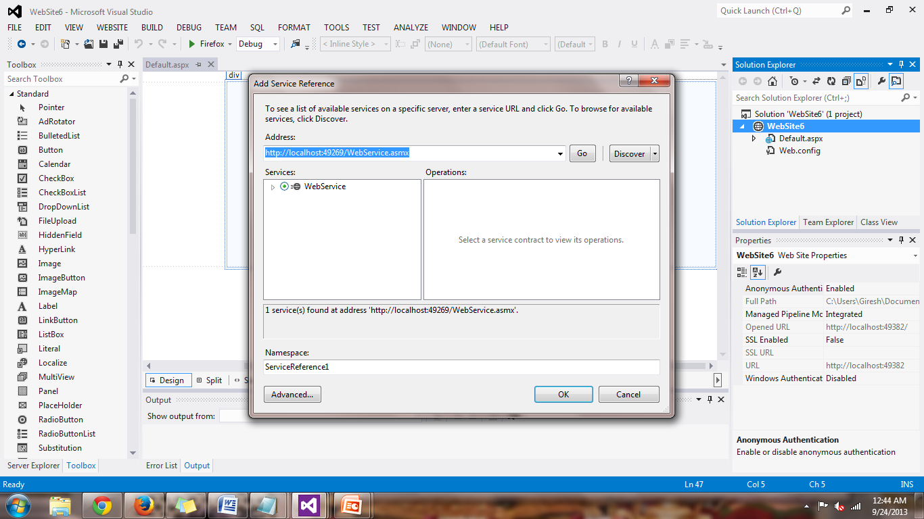

After adding web references we can see the following methods

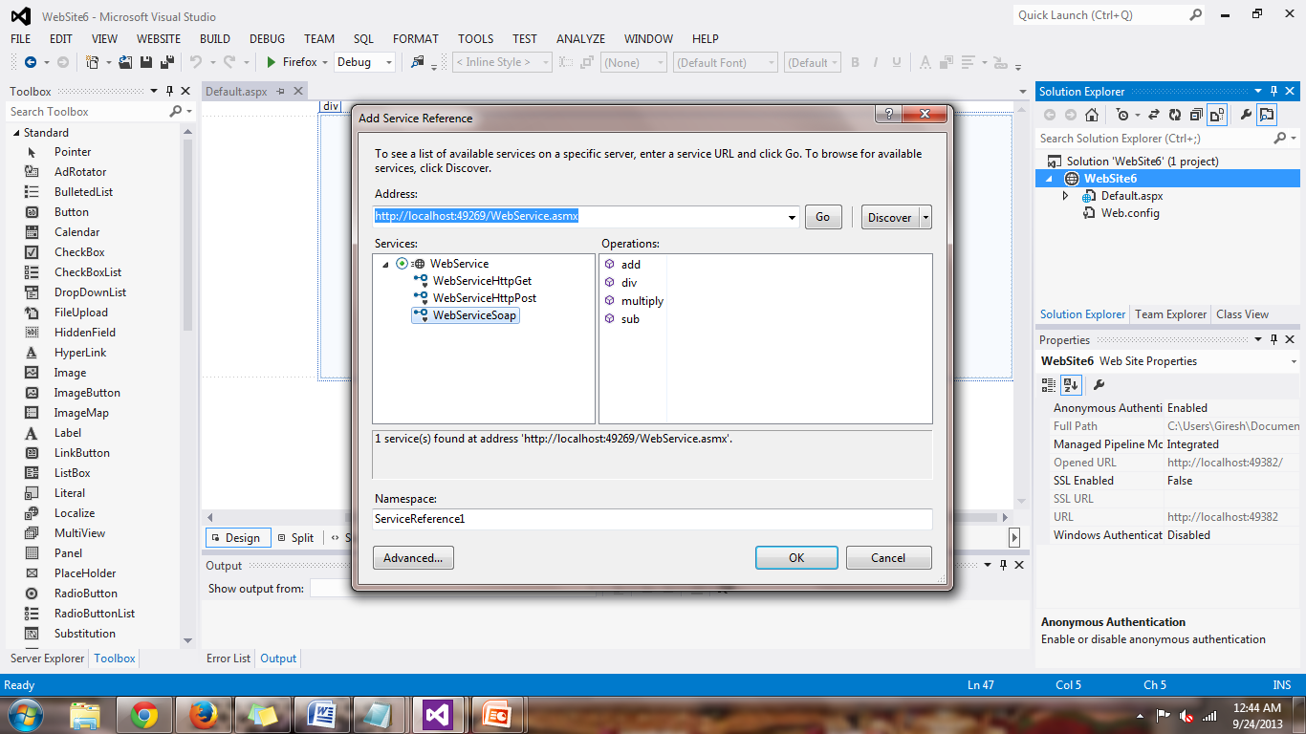

Then write the code that corresponds to the web page we created . Save the file and build solution

**Rest Service**

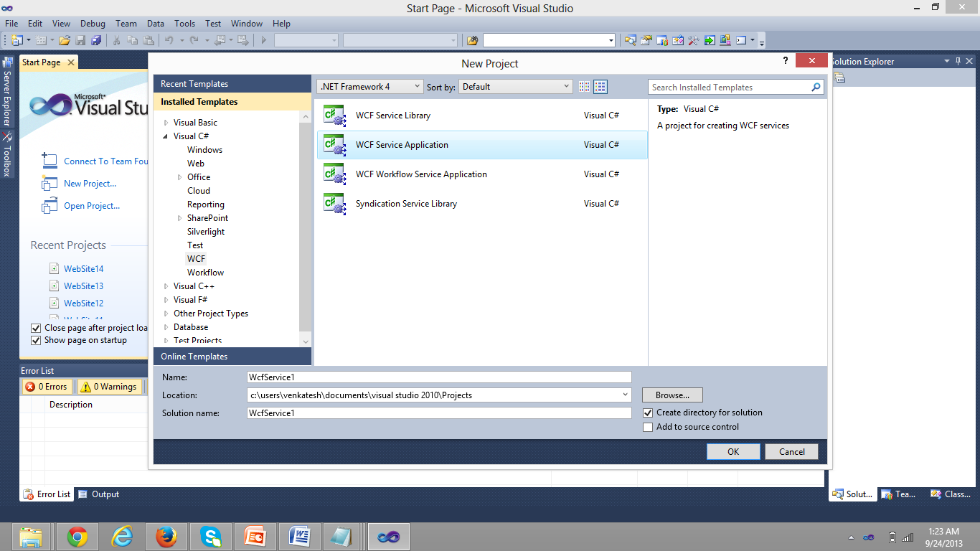I have created a REST web service called Web Service1.

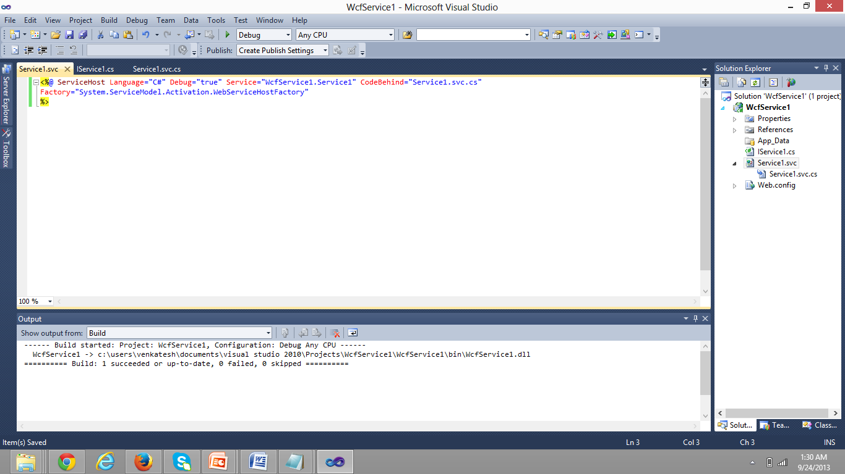

Then add a factory method in Service1.cs file as shown above .

Then I deployed it into Cloud and I converted it into application and then browsed it .

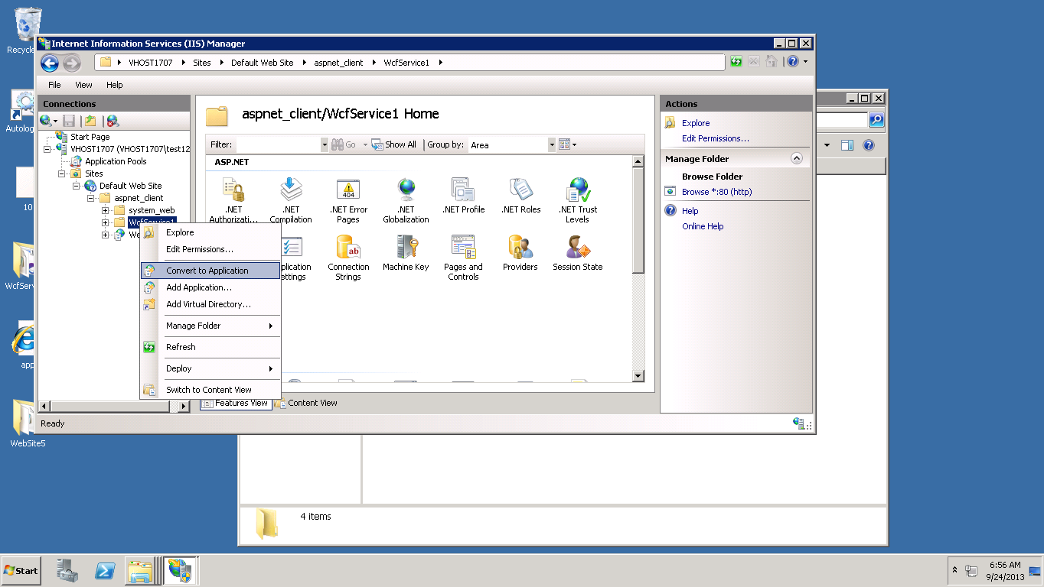

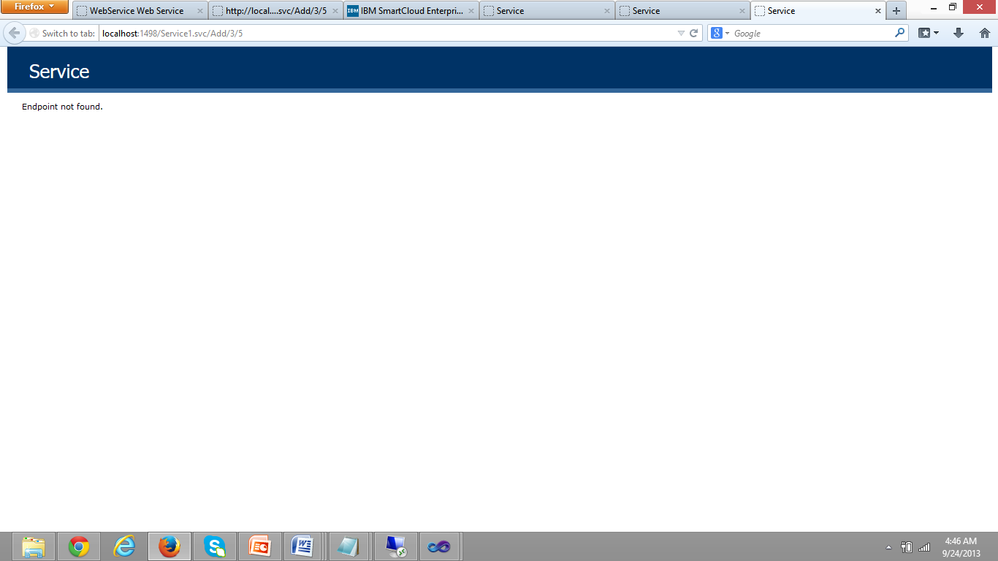

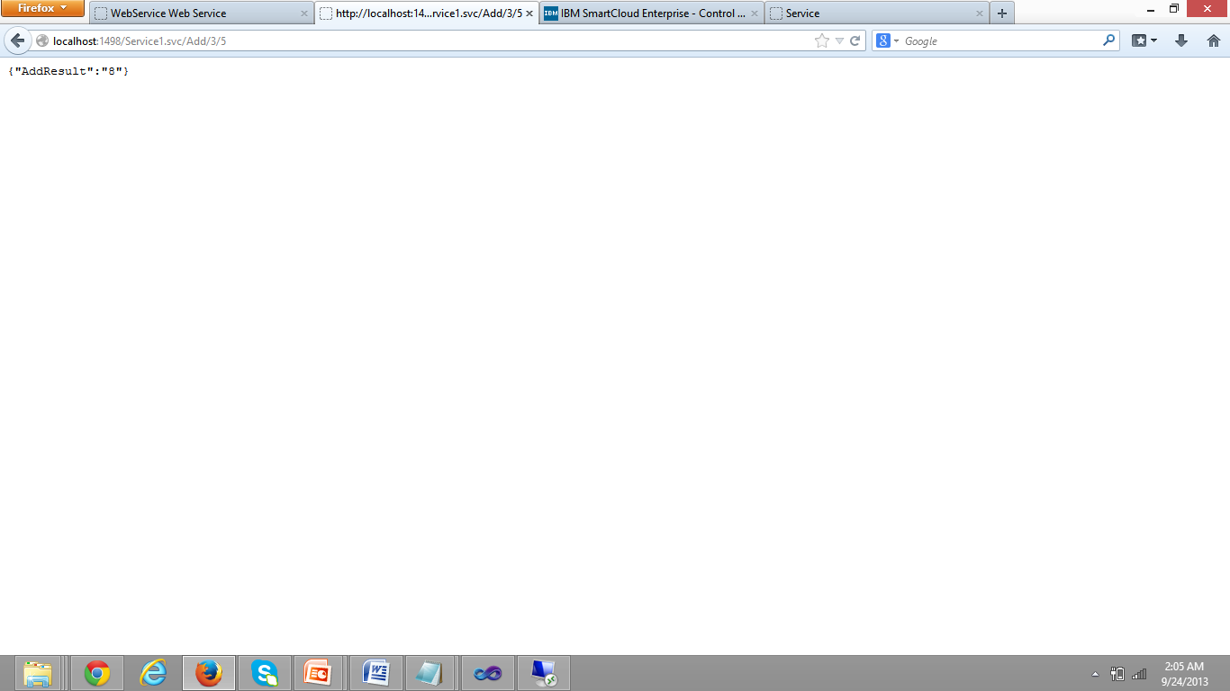

The REST Service link is

http://vhost1707.site1.compute.ihost.com/aspnet_client/WcfService1/Service1.svc/Add/16/1